**Practical-1**

**Aim: Write a C program to input any character and check whether it is the alphabet, digit, or special character.**

**Program:**

#include<stdio.h>

#include<conio.h>

main()

{

char type;

clrscr();

printf("=> Enter any character :- ");

scanf("%c",&type);

if( ( type>='a' && type<='z' ) || ( type>='A' && type<='Z') )

{

printf("\n=> %c character is an alphabet.",type);

}

else if( (type>='0') && (type<='9') )

{

printf("\n=> %c character is a digit.",type);

}

else

{

printf("\n=> %c character is a special character.",type);

}

getch();

}

**Output:**

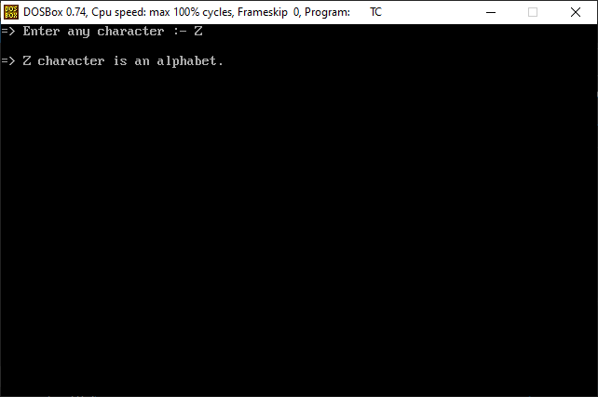

**Practical-2**

**Aim: Write a C program to check a number is even or odd using the ternary operator.**

**Program:**

#include<stdio.h>

#include<conio.h>

main()

{

int num;

clrscr();

printf("=> Enter any number :- ");

scanf("%d",&num);

(num%2 == 0)

? printf("\n=> %d number is even number.")

: printf("\n=> %d number is odd number.t");

getch();

}

**Output:**

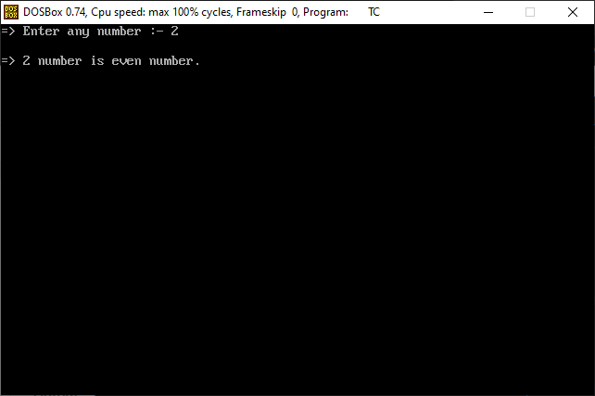

**Practical-3**

**Aim: Write a C program to find out the min from 4 numbers using the ternary operator. Also, provide proper validation layers.**

**Program:**

#include<stdio.h>

#include<conio.h>

main()

{

int a,b,c,d;

clrscr();

printf("=> Enter the value of a :- ");

scanf("%d",&a);

printf("=> Enter the value of b :- ");

scanf("%d",&b);

printf("=> Enter the value of c :- ");

scanf("%d",&c);

printf("=> Enter the value of d :- ");

scanf("%d",&d);

(a>b)

? (a>c)

? (a>d)

? printf("\n=> a value is maximum.")

: printf("\n=> d value is maximum.")

: (c>d)

? printf("\n=> c value is maximum.")

: printf("\n=> d value is maximum.")

: (b>c)

? (b>d)

? printf("\n=> b value is maximum.")

: printf("\n=> d value is maximum.")

: (c>d)

? printf("\n=> c value is maximum.")

: printf("\n=> d value is maximum.");

getch();

}

**Output:**

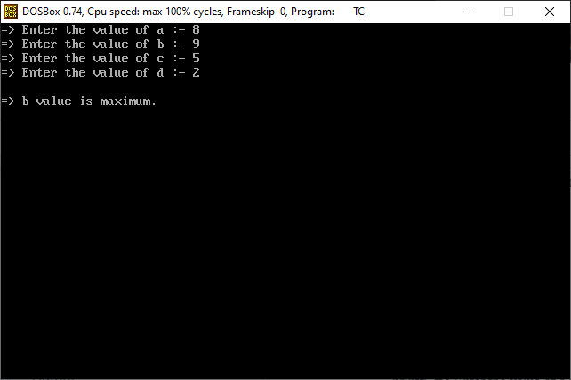

**Practical-4**

**Aim: Write C program use switch statement. Display months name. Also, provide proper validation layers.**

**Ex. User Input: M**

**Output: March**

**Program:**

#include<stdio.h>

#include<conio.h>

main()

{

char month;

clrscr();

printf("Press 'J' for January.\n");

printf("Press 'F' for February.\n");

printf("Press 'M' for March.\n");

printf("Press 'A' for April.\n");

printf("Press 'Y' for May.\n");

printf("Press 'U' for June.\n");

printf("Press 'L' for July.\n");

printf("Press 'G' for August.\n");

printf("Press 'S' for September.\n");

printf("Press 'O' for October.\n");

printf("Press 'N' for Nevember.\n");

printf("Press 'D' for December.\n");

printf("\n\n=> Enter any month letter :- ");

scanf("%c",&month);

switch(month)

{

case 'J':

printf("\n=> You entered January month.");

break;

case 'F':

printf("\n=> You entered February month.");

break;

case 'M':

printf("\n=> You entered March month.");

break;

case 'A':

printf("\n=> You entered April month.");

break;

case 'Y':

printf("\n=> You entered May month.");

break;

case 'U':

printf("\n=> You entered June month.");

break;

case 'L':

printf("\n=> You entered July month.");

break;

case 'G':

printf("\n=> You entered August month.");

break;

case 'S':

printf("\n=> You entered September month.");

break;

case 'O':

printf("\n=> You entered October month.");

break;

case 'N':

printf("\n=> You entered Nevember month.");

break;

case 'D':

printf("\n=> You entered December month.");

break;

default:

printf("\n=> Plese enter valid option...");

break;

}

getch();

}

**Output:**

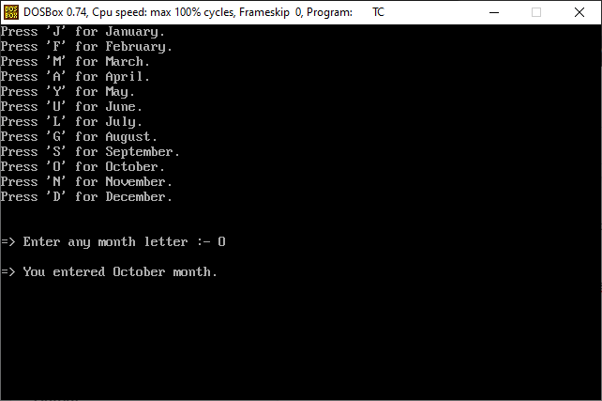

**Practical-5**

**Aim: Write a C program to input electricity unit charges and calculate the total electricity bill according to the given condition:**

**For the first 50 units Rs. 0.50/unit**

**For the next 100 units Rs. 0.75/unit**

**An additional surcharge of 20% is added to the bill.**

**Program:**

#include<stdio.h>

#include<conio.h>

main()

{

float unit,ans,sum,bill;

clrscr();

printf("=> Enter your electricity unit :- ");

scanf("%f",&unit);

if(unit<=50)

{

sum=unit*0.5;

ans=(20*sum)/100;

bill=sum+ans;

printf("\n=> Your total bill is = %.2f",bill);

}

else if(unit<=150)

{

sum=25+(unit-50)*0.75;

ans=(20*sum)/100;

bill=sum+ans;

printf("\n=> Your total bill is = %.2f",bill);

}

getch();

}

**Output:**

